scaling drupal step three - using heartbeat to implement a redundant load balancer
if you've setup a clustered drupal deployment (see scaling drupal step two - sticky load balancing with apache mod_proxy), a good next-step, is to cluster your load balancer.
one way to do this is to use heartbeat to provide instant failover to a redundant load balancer should your primary fail. while the method suggested below doesn't increase the loadbalancer scalability, which shouldn't be an issue for a reasonably sized deployment, it does increase your the redundancy. as usual, my examples are for apache2, mysql5 and drupal5 on debian etch. see the scalability overview for related articles.

deployment overview
this table summaries the characteristics of this deployment choice
scalability: | fair
redundancy: | good
ease of setup: | fair

servers
in this example, i use:
web server | drupal-lb1.mydomain.com | 192.168.1.24
web server | drupal-lb2.mydomain.com | 192.168.1.25
data server | drupal-data-server1.mydomain.com | 192.168.1.26
load balancer | apache-balance-1.mydomain.com | 192.168.1.34
load balancer | apache-balance-2.mydomain.com | 192.168.1.35
load balancer cluster | apache-balance-cluster.mydomain.com | 192.168.1.51

network diagram
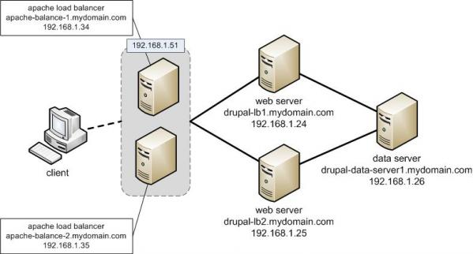

install and setup heartbeat on load balancers
setup two load balancers, apache-balance-1 and apache-balance-2 as described in my previous blog. install heartbeat and it's dependencies on both:
# apt-get install heartbeat-2
configure /etc/ha.d/ha.cf (see http://www.linux-ha.org/GettingStarted for more info) identically on each of the load balancers as follows:
logfile /var/log/ha-log
bcast eth0
keepalive 2
warntime 10
deadtime 30
initdead 120
udpport 694
auto_failback yes
node apache-balance-1
node apache-balance-2
uuidfrom nodename
respawn hacluster /usr/lib/heartbeat/ipfail
note:
- the nodenames must be the output of uname -n
- i had problems with my nodenames flapping, using uuidfrom fixed this.
configure /etc/ha.d/haresources. this must be identical on apache-balance-1 and apache-balance-2. really! . this file should look like:
apache-balance-1 192.168.1.51 apache2
note:
- apache-balance-1 here refers to the "preferred" host for the service
- 192.168.1.51 is the vip that your load balancer will appear to be on
- apache2 here refers specifically to the name of the script in the directory /etc/init.d
configure /etc/ha.d/authkeys on both load balancers. if you're paranoid, see more secure options, in "configuring authkeys" here. this fiile should look like:
auth 2
2 crc
set authkeys permissions on both load balancers:
# chmod 600 /etc/ha.d/authkeys
configure apache to listen on the vip. edit /etc/apache2/ports.conf on both load balancers:
Listen 192.168.1.51:80
note: after this change, apache won't start on the load balancer in question, unless it has the vip. relax. that's as it should be.
theoretically you should configure each load balancer to stop apache2 starting on boot. this allows the ha daemon to take full control of starting and stopping apache. in practice i didn't need to. you might want to.

restart the ha daemons and test
restart the ha daemon on both load balancers and test:
# etc/init.d/heartbeat restart
keep an eye on the apache and heartbeat logfiles on both servers to see what is going on when you shut either loadbalancer down.
# tail -f /var/log/apache2/access.log
# tail -f /var/log/ha-log

final word
this is a fairly simplistic configuration. there is more you can do on detecting abormal situations and failing over. for more information, visit http://www.linux-ha.org

